**Dissertation Report**

**ON**

**“Online Evaluation System for Descriptive Answers”**

**Submitted By**

**Gaurav Ramkrushna Gadge**

**MCA II (Semester-IV)**

**Guided By**

**Mr. Nakul W. Deshmukh**

**iBase Electrosoft LLP.**



**P. G. Department of Computer Applications**

**Prof. Ram Meghe Institute of Technology & Research, Badnera**

**2021-2022**

**CERTIFICATE**

***This is to certify that the project entitled***

**“Online Evaluation System for Descriptive Answers**”

***is a bonafide work and is submitted to***

***Sant Gadge Baba Amravati University, Amravati***

***in partial fulfilment of the requirement for Master in Computer Application***

***during the academic year* 2021-2022**

**SUBMITTED BY**

**Gaurav Ramkrushna Gadge**

**MCA II (Sem-IV)**



***Mr. Nakul W. Deshmukh Prof. R.R.Sherekar***

***iBase Electrosoft LLP.***

Guide Head

**-----------------**

**External**

**P. G. Department of Computer Applications**

**Prof. Ram Meghe Institute of Technology & Research, Badnera.**

ACKNOWLEDGEMENT

I take this opportunity to thank our project guide Mr. Nakul W. Deshamukh, ibase Electrosoft LLP. , Prof. R. R. Sherekar, Head of the P. G. Department of Computer Applications and Prof. S.S. Tayade for their valuable guidance and for providing all the necessary facilities, which were indispensable in the completion of this project. I am also thankful to all staff members of P. G. Department of Computer Applications, Prof. Ram Meghe Institute of Technology & Research, Badnera for their valuable time, support, comments, suggestions and persuasion. I express my gratitude towards all who helped us directly or indirectly in the completion of this project work successfully.

**Submitted By**

**Gaurav Ramkrushna Gadge**

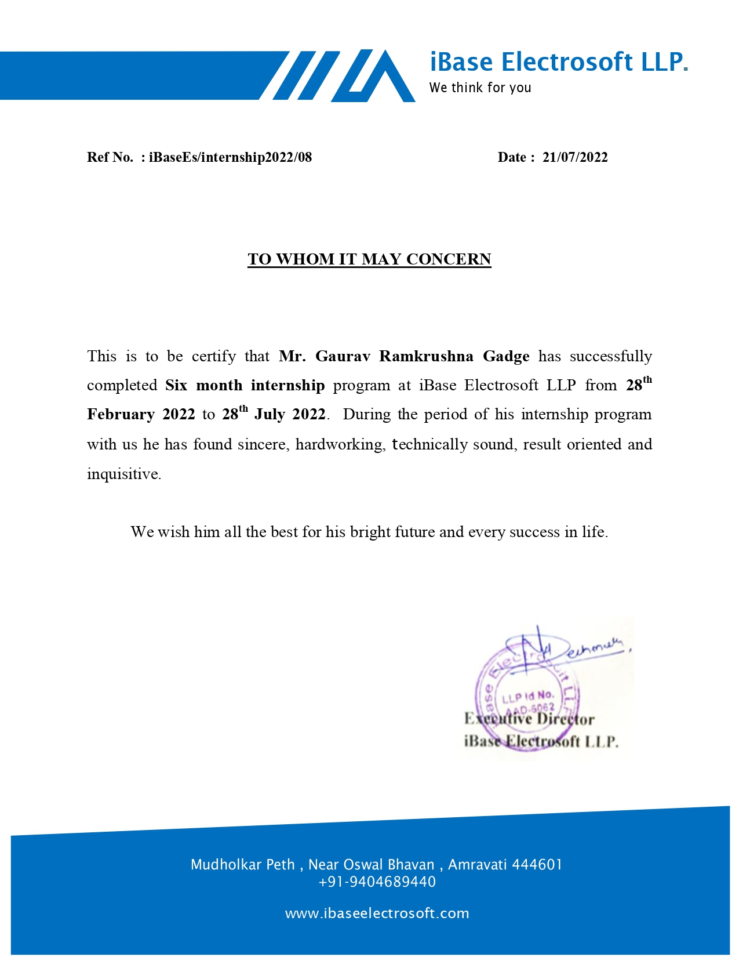

**INDEX**

|  |  |  |  |
| --- | --- | --- | --- |
| **Sr. No.** | | **Topic** | **Page No** |
|  |  | **Abstract** | **I** |
|  |  | **List of Screenshots** | **II** |
|  |  | **List of Figures** | **III** |
|  |  | **List of Abbreviations** | **IV** |
| **1** |  | **Introduction** | **1** |
|  | **1.1** | **Overview** | **2** |
|  | **1.2** | **Industry Profile** | **2** |
|  | **1.3** | **Problem Definition** | **2** |
|  | **1.4** | **Project Scope** | **2** |
|  | **1.5** | **Motivation** | **3** |
| **2** |  | **System Analysis** | **4** |
|  | **2.1** | **Exam System Admin** | **5** |
|  | **2.2** | **Staff** | **6** |
|  | **2.3** | **Student** | **8** |
|  | **2.4** | **Online Exam Portal** | **9** |
| **3** |  | **System Requirement Specification** | **14** |
|  | **3.1** | **Hardware & Software Requirement** | **15** |
| **4** |  | **System Design** | **16** |
|  | **4.1** | **Database** | **16** |
|  | **4.2** | **Proposed Functionality** | **17** |
| **5** |  | **Input& output** | **18** |
| **6** |  | **Advantages & Disadvantages** | **19** |
| **7** |  | **Conclusion & Future Scope** | **18** |
| **8** |  | **References** | **20** |

**Abstract**

Online subjective tests are very rarely proposed. All the online subjective exams set for the students are pen and paper based evaluated by the teachers manually. This paper presents a survey on effective way of online subjective tests. In this, the answers are unstructured data which have to be evaluated. The evaluation is based on the semantic similarity between the faculty’s answers and students’ answers. Different techniques are compared and a new approach is proposed to evaluate subjective test assessment of text.

**List of Screenshots**

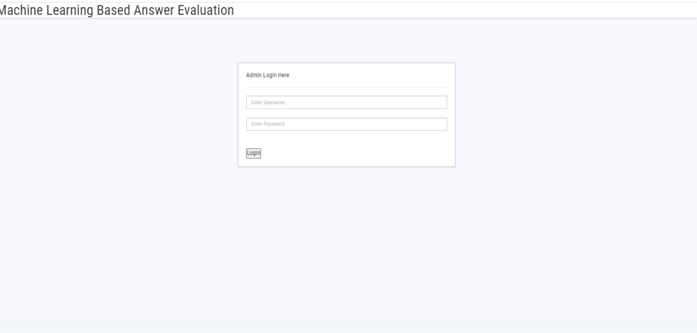

Fig. 1.1 Admin Login page

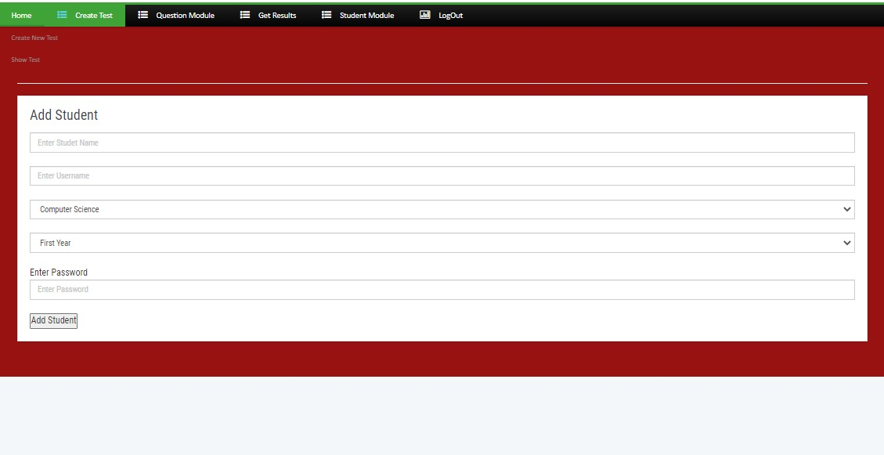

Fig. 1.2 Student Register

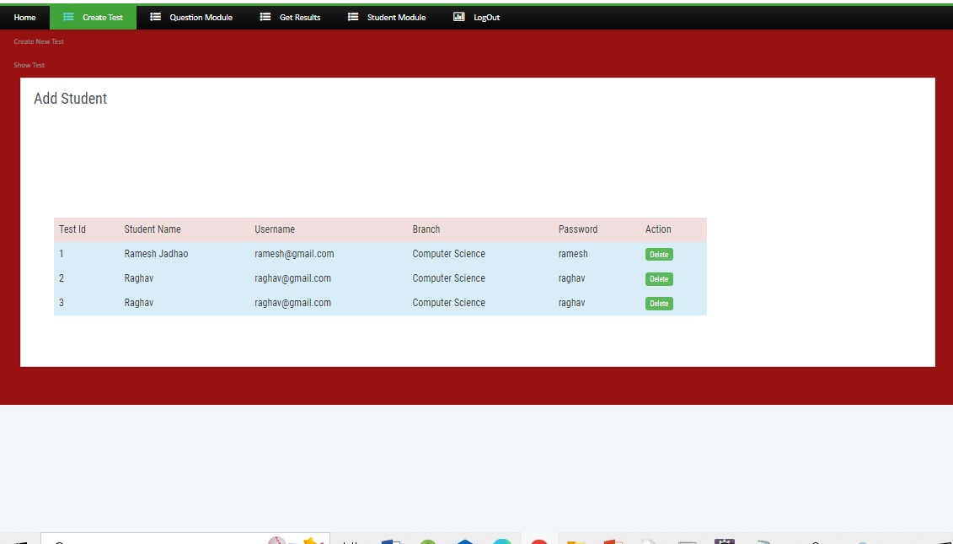

Fig. 1.3 Register student list

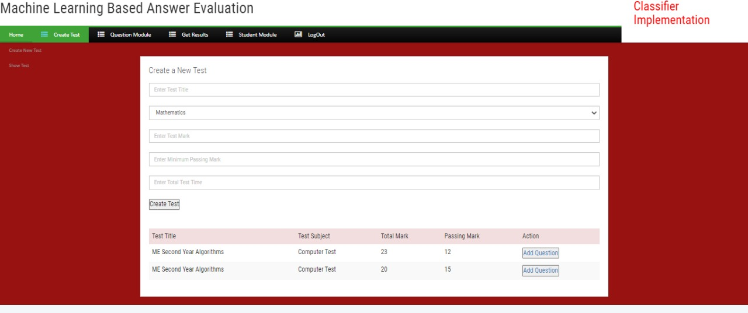

Fig.1.4 Create new test

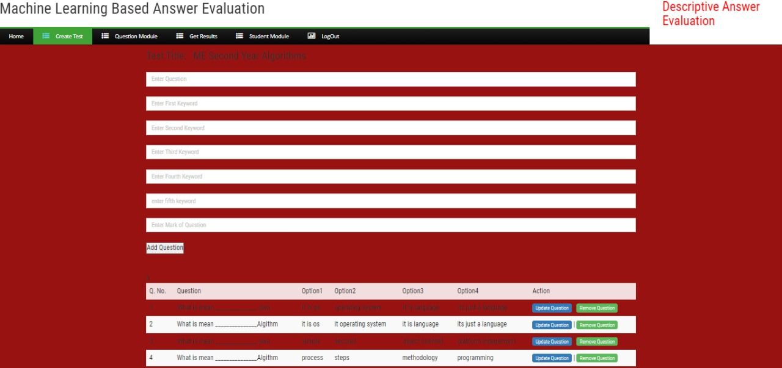

Fig1.5 add question in test page

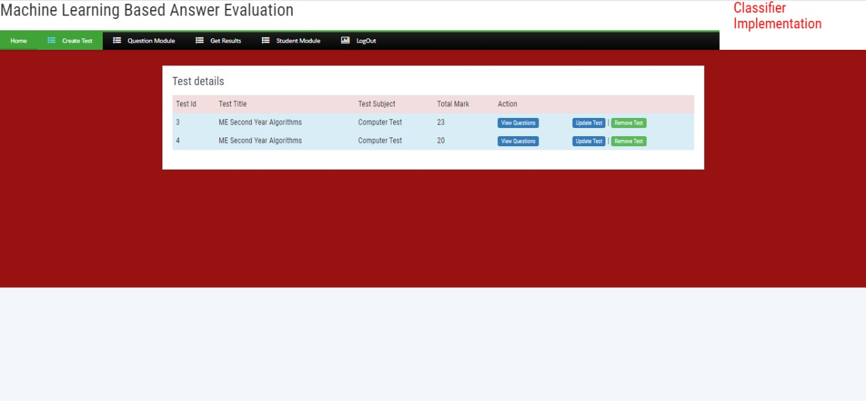

Fig 1.6 Test details

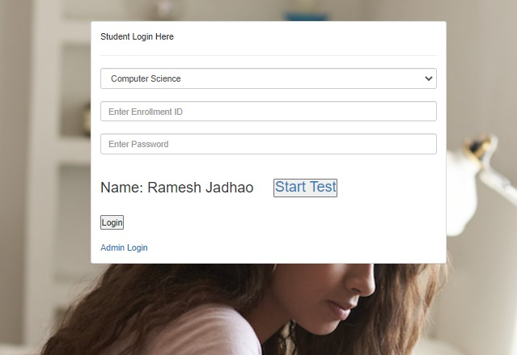

Fig. 1.7 Student login

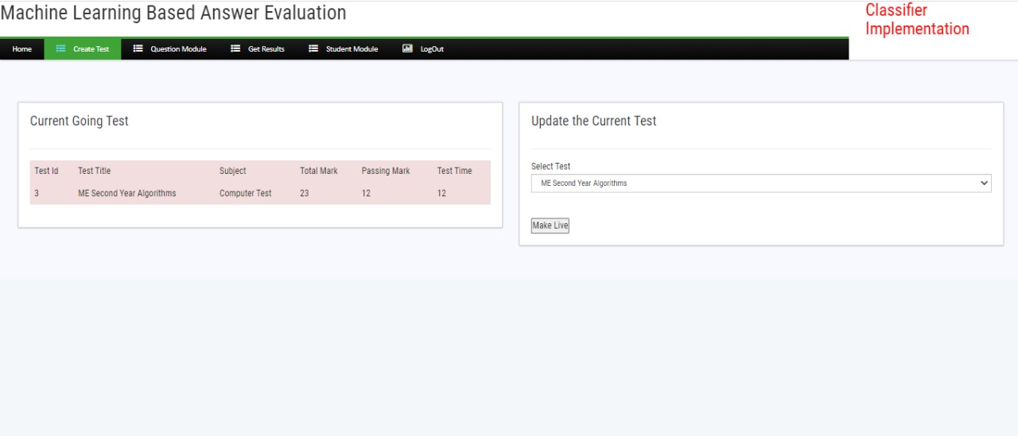

Fig.1.8 Show current test

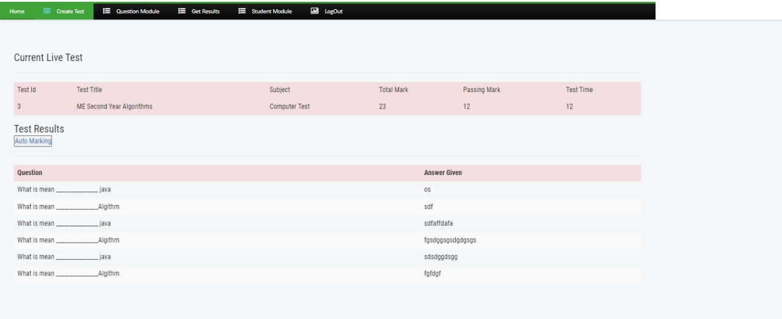

Fig.1.9 Test page

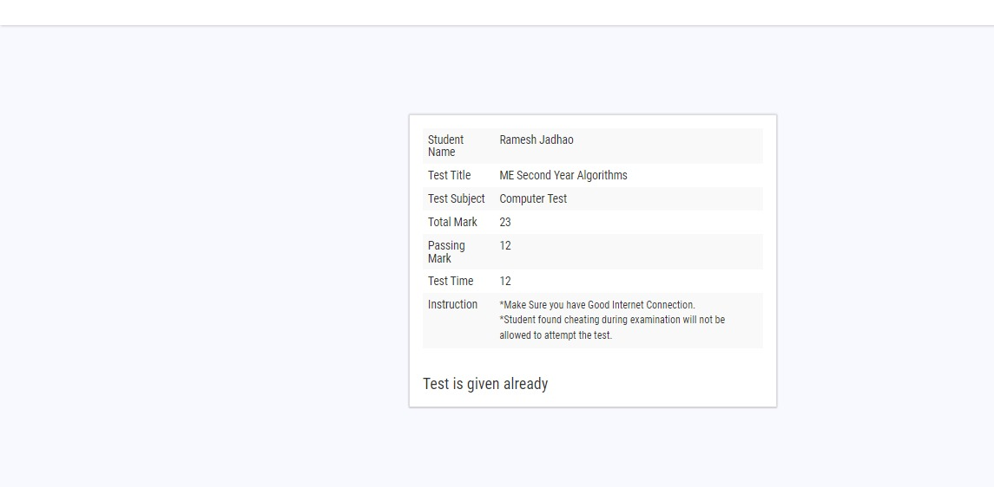

Fig.1.10 show current page



Fig.2.1 Again admin login

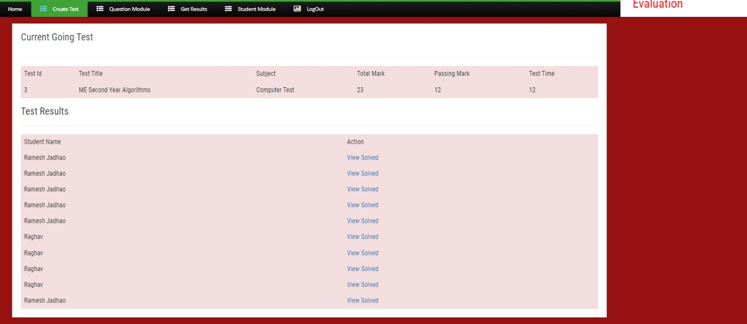

Fig. 2.2view test of student

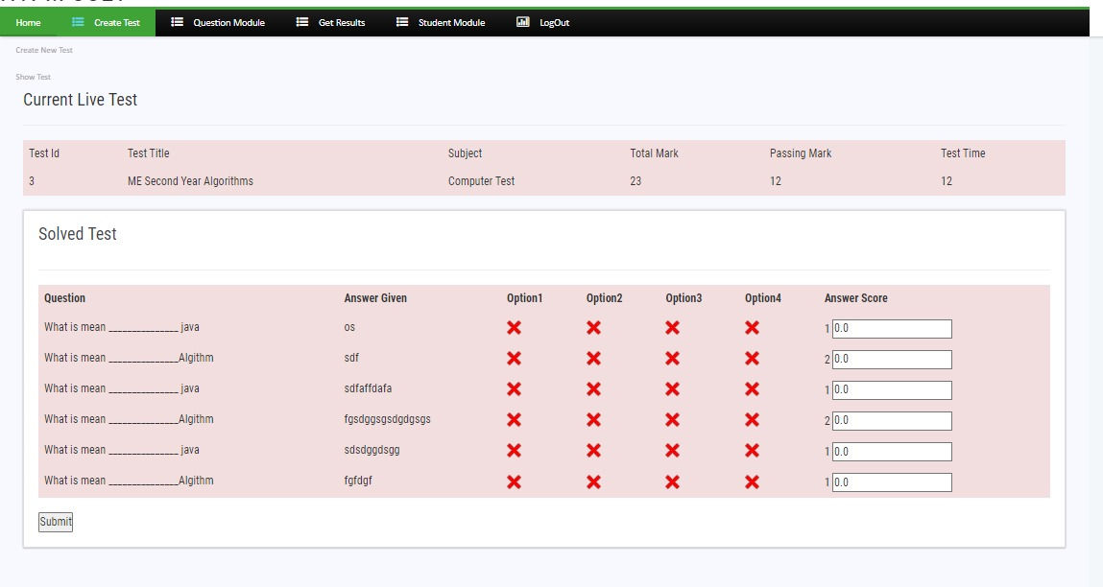

Fig.1.3 viewed solved

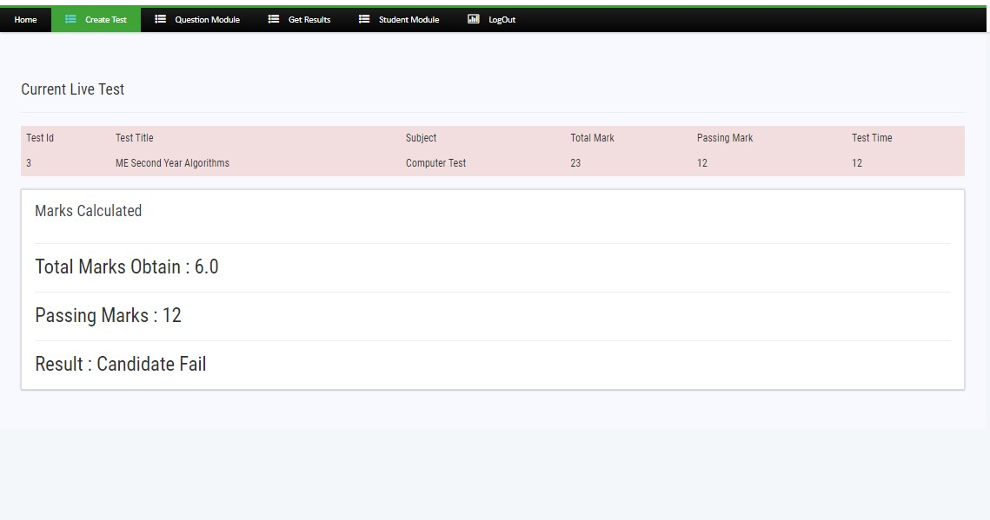

Fig.2.4 view the result

**List of Figures**

**Java**

**Server.config**

**Data Access.DDL**

**Fig. Component Diagram of Right To Information**

**Client (Student)**

**Server**

**Database**

**Fig. Deplovment Diagram of Right To Information**

**List of Abbreviation**

1. DMS : Document Management System.
2. HTML : Hyper Text Markup Language.
3. CSS : Cascading Style Sheet.
4. RAM : Random Access Memory.
5. SRS : Software Require Specification.
6. OS : Operating System.